SMARTPHONE

**☞🕮☜**

Buger guider

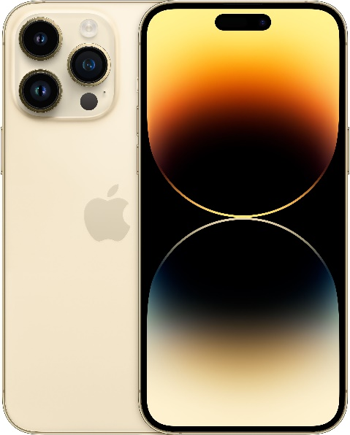



**samsung s23 ultra**

**Iphone 14 pro max**

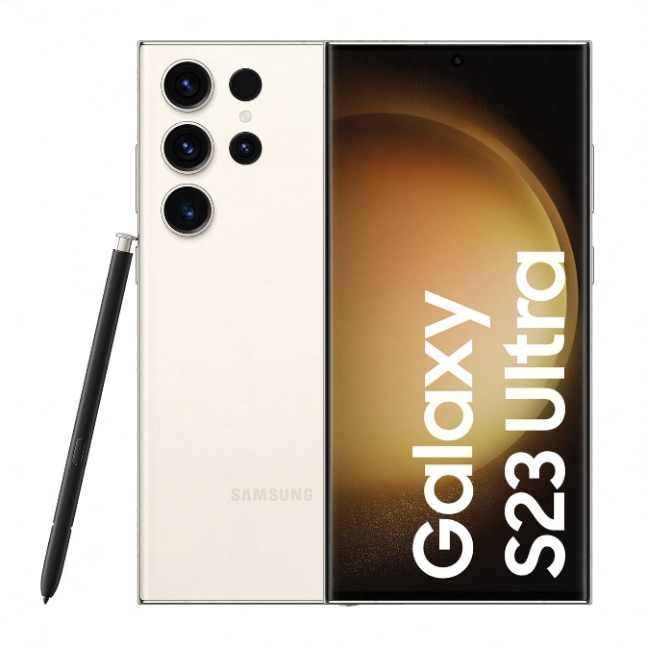

SENGHAK CHHUN

**Contents**

**1.** **Presentation of the products** 2

**1.1 Iphone 14 Pro Max** 2

**1.2 Samsung s23 ultra** 2

**2.** **Which guitar should you buy ?** 3

**3.** **Let s talk about smartphone** 3

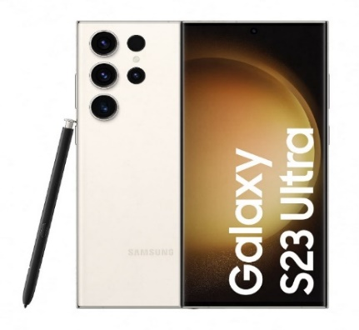

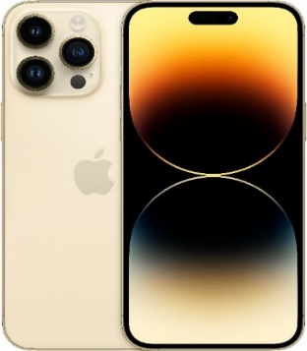

# **Presentation of the products**

## **1.1 Iphone 14 Pro Max**



highlighting the major new feature[1] such as an always-on display with a new Dynamic Island, upgraded cameras with a 48-megapixel main lens, car crash detection and satellite connectivity for emergencies, the A16 Bionic chip for faster performance, and new Deep Purple and Space Black color options.

**Iphone 14 Pro Max**

Iphone 14 promax

## **1.2 Samsung s23 ultra**



Apple iPhone 14 Pro Max vs. Samsung Galaxy S23 Ultra ...The intricacies of image quality aside, the Galaxy S23 Ultra is objectively the more versatile [2]camera phone. While the 14 Pro Max has three cameras - a standard one, an ultrawide, and a 3x zoom telephoto, the S23 Ultra tops that with a 10x periscope camera, so you get one extra focal length

Samsung Galaxy S23 ultra

# **Which smartphone should you buy ?**

Both are good to use and the camera is similar in quality, but the price of samsung is up to $ 100 more than the iphone. However, the iphone and samsung are still very popular and willl have a nice appearance that makes it lots of interest from customers in the world. And I phone have sold 26.09 million units. samsung Galaxy s23 ultra have sold sold 1.65 million units.

|  |  |  |
| --- | --- | --- |
|  | Apple iPhone 14 Pro Max 128GB Gold (T-Mobile) MQ8Q3LL/A - Best Buy | Samsung Galaxy S23 Ultra 5G (Cream, 12GB, 256GB Storage) : Amazon.in:  Electronics |
| Weight | 240g | 234g |
| Dustwater resistant | Up to 6 m for 30 min | 1.5m for 30 min |
| OS | IOS 16, upgradable to IOS 16.4.1 | Android 13, one uI 5.1 |
| Memory | 128GB 6GB RAM, 256GB 6GB RAM, 512GB 6GB RAM, 1TB 6GB RAM | 256GB 8GB RAM, 256GB 12GB RAM, 512GB 12GB RAM, 1TB 12GB RAM |
| Main camera | 48 MP, F/1.8, 24 mm (wide), 1/1.28”, | 200 MP, F/1.7, 24 mm (wide), 1/1.3”, |
| Colors | Space Black, Silver, Gold, Deep Purple | Phantom Black, Green, Cream, Lavender, Graphite, Sky Blue, Lime, Red |
| Price | 999$, 1099$, 1299$, 1499$ | 1029$, 1129$, |
| Battery Life | [121h endurance rating](https://www.gsmarena.com/apple_iphone_14_pro_max-review-2482p3.php#bl) | [126h endurance rating](https://www.gsmarena.com/samsung_galaxy_s23_ultra-review-2526p3.php#bl) |

# **Let s talk about smartphone**

**Iphone 14 pro max is my Favorite smartphone**

Why do you like iphone 14 pro max?

I like iphone 14 pro max because It my favrito phone that I want to use it. And one more camera and shape of phone is good. I can you it in my work too.

Why iphone 14 pro max is favorite to use?

Because It good for complete work and play game, listen music.



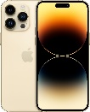

**Samsung Galaxy s23 ultra is amzing.**



Why do you like samsung Galaxy S23 ultra?

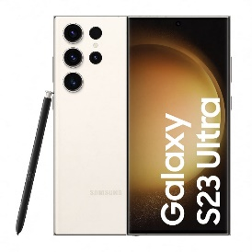I like samsung like camera it good I can take photos clear and can work with phone too. It have good shape retangle that is good.

Why Samsung Galaxy S23 ultra is favorite

to use?

Becuse I like it. I want to use it.

But now no money to buy it.

1. Feature : a distinctive attribute or aspect of something
2. Versatile​​​ : able to adapt or be adapted to many different functions or activities.